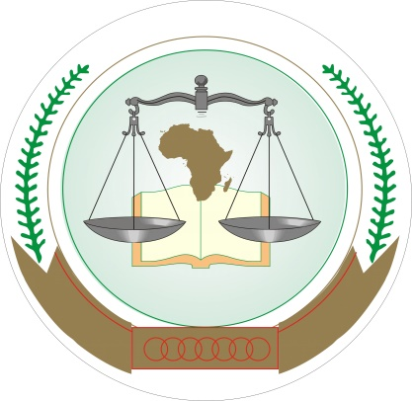
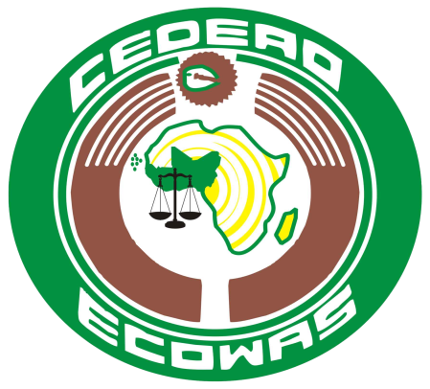

JOINT COMMUNIQUE OF THE AFRICAN COURT ON HUMAN AND PEOPLES’ RIGHTS AND THE COMMUNITY COURT OF JUSTICE, ECOWAS

- A delegation of the ECOWAS Court of Justice led by its President, Hon. Justice Jérôme Traoré, and composed of five other Judges and senior Registry staff, including the Chief Registrar, undertook a working visit to the African Court on Human and Peoples’ Rights based in Arusha, Tanzania, from 26 February to 1 March, 2018. During the visit, the Judges of the two Courts discussed a wide range of issues pertaining to their respective mandates. In particular, there was a presentation of the two courts and discussions around the human rights jurisprudence of both Courts; the overlapping jurisdictions and the mechanisms put in place for the implementation of their decisions.

- The Registry staff from the Registries of the two Courts also met at the technical level to exchange views on how to effectively provide technical and judicial support to the Courts.

- The visit culminated in the signing of a Memorandum of Understanding (MoU) on 1 March, 2018, for an initial three year period, which entered into force on the date of signing. Through the MOU, both courts committed to strengthening their already good relationship, and to this end, agreed to a number of initiatives to enhance the discharge of their respective mandates, through the concerted implementation of programmes that will enable them contribute towards improving human rights in the continent.

- Among the areas identified for cooperation are staff exchanges, reciprocal representation, knowledge and information sharing, research and capacity building within the framework of the constitutive instruments of both courts.

- In order to operationalise their commitment in the areas of capacity building and training, the two courts agreed to jointly mobilise resources for the execution of joint projects.

- They also agreed to establish a Joint Committee charged with the institutionalization of consultations and ensuring the effectiveness of their cooperation.

- The delegation of the ECOWAS Court also visited two international tribunals based in Arusha, that is, the East African Court of Justice and the UN-Mechanism for International Criminal Tribunals (UN-MICT).

DONE AT ARUSHA, THIS FIRST DAY OF MARCH, 2018.

