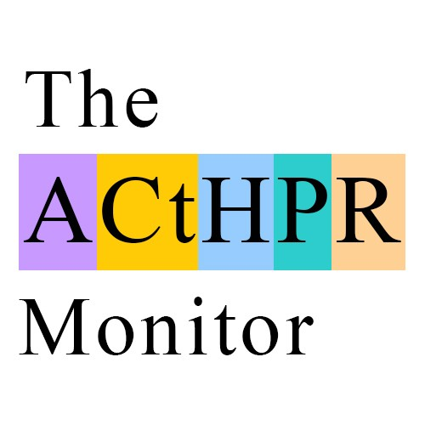
Independent news, comment and debate on the African Court on Human and Peoples’ Rights
www.acthprmonitor.org

African Commission on Human and Peoples’ Rights
Via email au-banjul@africa-union.org;
africancommission@yahoo.com; and
tesfayea@africa-union.org
29 June 2016

Dear Sir or Madam

Public Consultation on the Zero Draft of the General Comment on the Right to Redress for Victims of Torture or Ill-treatment under Article 5 of the African Charter on Human and Peoples’ Rights

Following the African Commission on Human and Peoples’ Rights’ (“African Commission”) call for public consultation, we have read with interest the African Commission’s Zero Draft of the General Comment on the Right to Redress for Victims of Torture or Ill-treatment under Article 5 of the African Charter on Human and Peoples’ Rights (“Draft”).

At The ACtHPR Monitor we believe the African Court on Human and Peoples’ Rights (“African Court”) has the potential to be one of the most important courts in the world and can help protect the fundamental rights of all African people, including victims of torture.

Whilst the Draft correctly sets out the need for robust mechanisms which allow victims of torture to seek redress at the domestic level, it does not currently mention the important role that can be played by the African Court in assisting victims of torture.

As the African Commission will be aware, the African Court can consider cases alleging violations of the African Charter on Human and Peoples’ Rights (“African Charter”) and other international human rights instruments ratified by the AU member state in question. Given that Article 5 of the African Charter prohibits the use of torture, and many AU member states have also signed other international instruments which expressly prohibit the use of torture and provide for redress for victims, for example the Convention against Torture and Other Cruel, Inhuman or Degrading Treatment or Punishment, the African Court is ideally placed to act as a court of last resort in considering petitions from victims of torture.

We would therefore recommend that the next version of the Draft encourage all AU member states to ratify the Protocol to the African Charter on Human and Peoples' Rights on the Establishment of the African Court on Human and Peoples' Rights (“Protocol”). We also believe that states should be urged to make the declaration pursuant to Article 34 (6) of the Protocol, which allows individuals and NGOs with observer status direct access to the African Court (“Declaration”).

Of course, urging AU member states to ratify the Protocol and sign the Declaration does not in any way lessen the need for strong in-country mechanisms to allow victims of torture to seek redress domestically. However, by ratifying the Protocol and signing the Declaration AU member states will provide their citizens with a complete framework, from the domestic level to the continental level, to help them seek redress for breaches of their human rights. Within this framework, the ideal scenario naturally remains that proper recourse for claims of redress for victims of torture can be effected in-country, but by giving citizens access to the African Court, each AU member state will ensure that victims of torture who cannot gain proper redress in their own country have the ability to take their case further and petition the African Court.

We at The ACtHPR Monitor would therefore encourage the drafters of this important General Comment to include within the final draft an unequivocal call on all AU member states to give full effect to the Protocol and Declaration to allow citizens who have been victims of torture the capability to bring cases to the African Court as part of the framework of human rights protections.

Should the African Commission or other stakeholders wish to discuss this comment we stand ready to assist.

Yours faithfully

Oliver Windridge
Founder
Independent news, comment and debate on the African Court on Human and Peoples’ Rights
www.acthprmonitor.org @acthpr_monitor

